Sean Blanchard

Roxanna Pinotti

5/23/2021

Big Bear Zoo Application Walkthrough

**MAIN MENU**

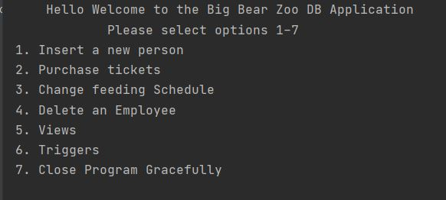

This is the main menu, most of your work will be done here. You can insert a new person into the database, you can purchase tickets, change a feeding Schedule, delete an employee, interact with different Views, interact with different Triggers, or close the application.

Let us try to insert a new person into the database, so I will press 1 and hit enter, followed by entering the persons information I am adding.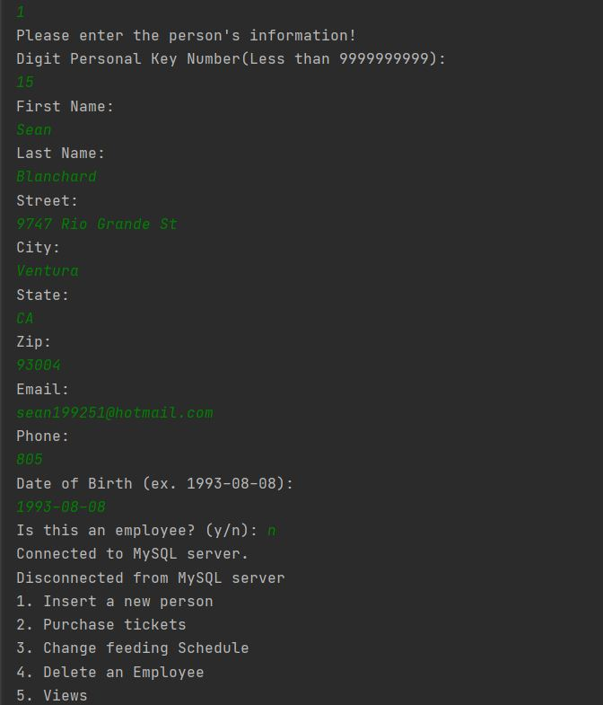

If we look at our database that is hosted on CIKEYS we can see that Sean Blanchard was added to the database. This is a easy way to add people in and out of the database quickly without knowing any SQL code.

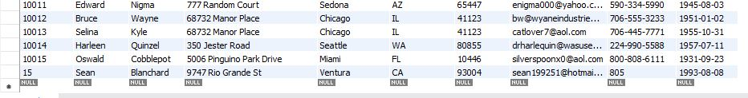

Let us say someone want to purchase tickets. You can do that by pressing 2 and hitting enter at the main menu. 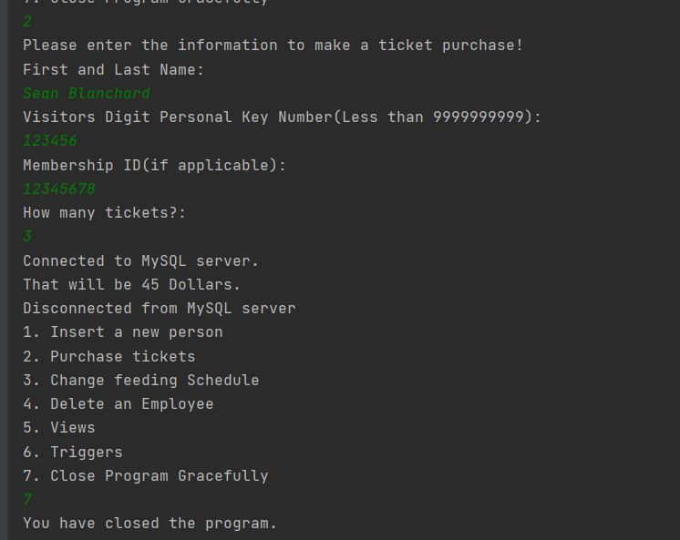

After this you can see, that information is added to the Visitor table and the Admission table after the successful purchase.

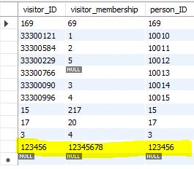

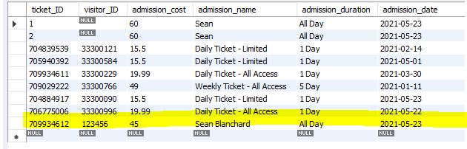

Next if we press 3, we can change the feeding schedule based on one already set up for that species ID.

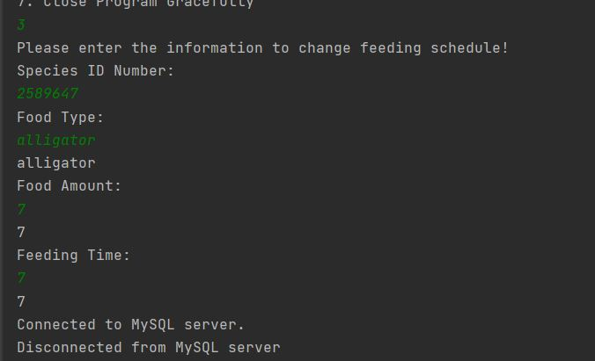

If we look below, we can see the non-updated feeding table on the left, and on the right the new updated feeding schedule.

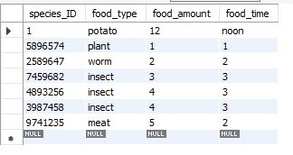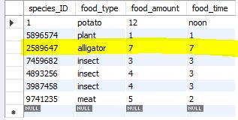

Next if we want to press 4 we can permanently delete an employee from the table, and the whole database for that fact.

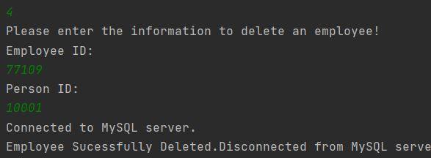

If we look below we can see we permanently deleted employee with employee id 77109, and person id 10001.

Here is a look at our employee table before(left) and after(right).

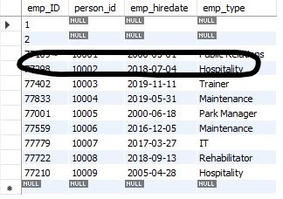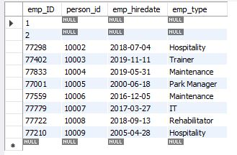

Here is a look at our people table before(top) and after(bottom). 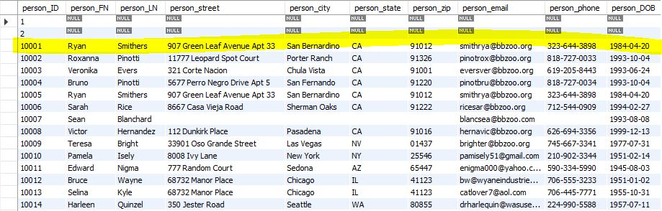

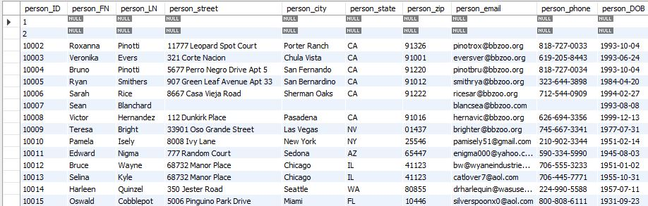

The application is also preloaded with 12 views. This is a fast way to grab everyday data that is needed on the job.

If we press 5, we can see we are greeted by the View menu. This has 12 preloaded views that all you must press is 1-13 to have it output queries for you. Some examples shown below, you are able to exit to main menu by pressing 13.

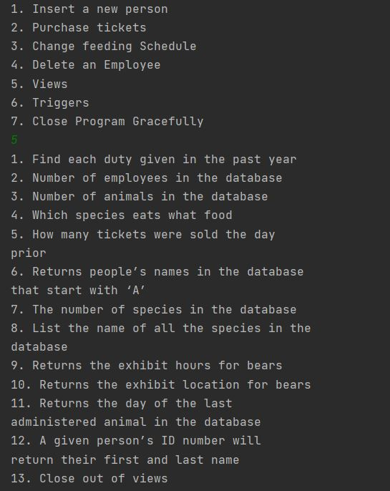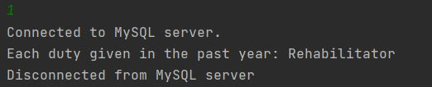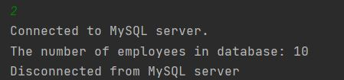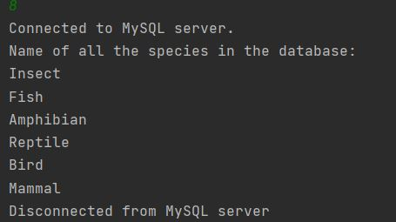

You can also make premade triggers in our app that help control the way information is passed though. To do this you press 6 on the main menu to get to the triggers menu.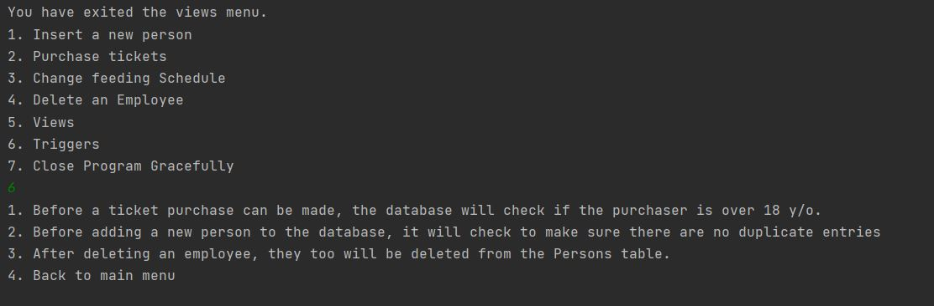

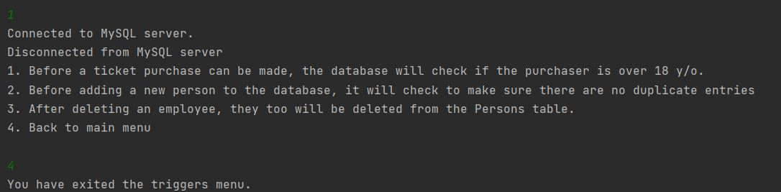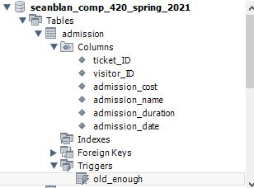

If you look above, you can see I added a trigger that will check that the purchaser is over 18 years old before they can purchase a ticket.

Lastly you can end the program by entering 7.  
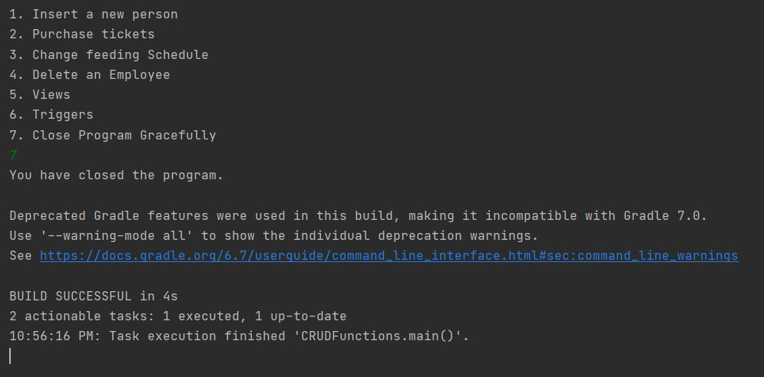

Thanks for looking at our application.